- In an IoT ecosystem, a trust model is implemented to establish trust
between IoT devices and a central server. The trust model uses a
reputation-based system, where each device accumulates trust points
based on its behavior over time. Device A currently has 500 trust points,
and Device B has 750 trust points. The trust model allows devices to
establish connections with other devices if their combined trust points
exceed a certain threshold of 1000 points. a) Will Device A and Device B
be able to establish a connection based on the trust models threshold?
b) If the trust threshold is increased to 1200 points, will they be able to
establish a connection? c) What is the minimum trust points Device C
should have to establish a connection with Device A, assuming Device A
maintains its XXX trust points?
Also In an IoT ecosystem, a trust model is implemented to establish trust
between IoT devices and a central server. The trust model uses a
reputation-based system, where each device accumulates trust points
based on its behavior over time. Device A currently has 500 trust points,
and Device B has 750 trust points. The trust model allows devices to
establish connections with other devices if their combined trust points
exceed a certain threshold of 1000 points. a) Will Device A and Device B
be able to establish a connection based on the trust model&#39;s threshold?
b) If the trust threshold is increased to 1200 points, will they be able to
establish a connection? c) What is the minimum trust points Device C
should have to establish a connection with Device A, assuming Device A
maintains its 500 trust points?

- In an IoT network, a system is using a symmetric encryption algorithm to
secure its communications. The system generates a new random
symmetric encryption key for each session. The key size is XXX bits.
Calculate the total number of possible keys that can be generated using
this key size. Also, if the system generates a new key for every hour,
calculate how long it would take for an attacker to exhaust all possible
keys through a brute-force attack if they can try 1 million keys per
second.
Also In an IoT network, a system is using a symmetric encryption algorithm to
secure its communications. The system generates a new random
symmetric encryption key for each session. The key size is 256 bits.
Calculate the total number of possible keys that can be generated using
this key size. Also, if the system generates a new key for every hour,
calculate how long it would take for an attacker to exhaust all possible keys through a brute-force attack if they can try 1 million keys per
second.

- If encrypted text PIPAF UIT is decrypted as NINAD SIR; with key = 2 , the find what
should be decrypted text if the encrypted text is “PIPAF UIT YAU VOWGJ”
with key = 2 and If key is ceil(XXX/100) then what will be new encryption

- Suppose you are designing a secure IoT system that uses encryption to
protect sensor data during transmission. You decide to use Advanced
Encryption Standard (AES) with a XXX-bit key for encryption and
decryption. Calculate the total number of possible keys in this AES
encryption scheme. Explain why using a longer key might be more secure.

- If the 1 bit left shift operation was carried out on the data and then all the
bits are reversed and again 1 bit right shift operation is carried out then
what will be final number generated at the output? Data=
11001100101010010101 Also use same IOT encryption to send current time HHMM as per your watch

- You have a fleet of XXX IoT sensors (1 year old) to be deployed in an
industrial setting, What will be the cost of implementing cloud security
measures for these devices for entire year. Given following details 1.
*Device Authentication*: Cost per device certificate: INR10 2. *Data
Encryption*: Cost of encryption key management system: INR 200/month
3. *Access Control*: Cost of access control system: INR 300/month 4.
*Intrusion Detection*: Cost of intrusion detection service: INR 50/month
per device 5. *Firmware Updates*: Cost of firmware update service: INR
100/device/year 6. *Data Privacy*: Cost of data anonymization service:
INR 5/device/month 7. *Backup and Recovery*: Cost of backup and
recovery service: INR 500/month 8. *Incident Response*: Cost of incident
response plan implementation: INR 2,000 - Cost of incident response
team per hour: INR 100/hour - Total response time for the year: 30
minutes/year 9. *Third-Party Audits*: Cost of third-party security audit:
INR 5,000/year
- If H(k) = floor(m*((K*A) mod 2)) and m=11 Slot= k mod m where K=5534 and A=0.XXX In which slot the particular function will map to?
- For the given graph find all possible Hamilton paths: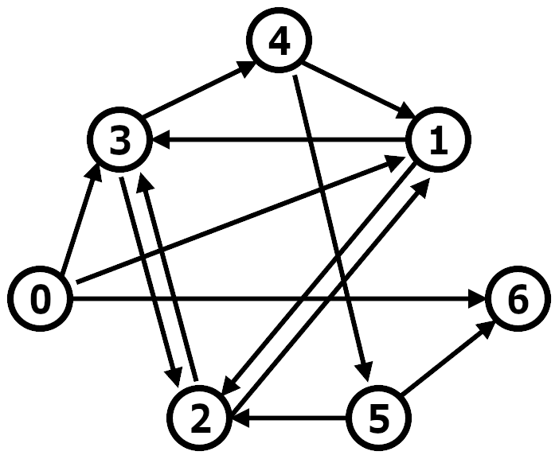
If the mapping is X1 to X3, X3 to X5 and so on similarly X2 to X4 and so on find final updated connection matrix

- Refer solved problem below and use ceil(XXX/10) instead of 11
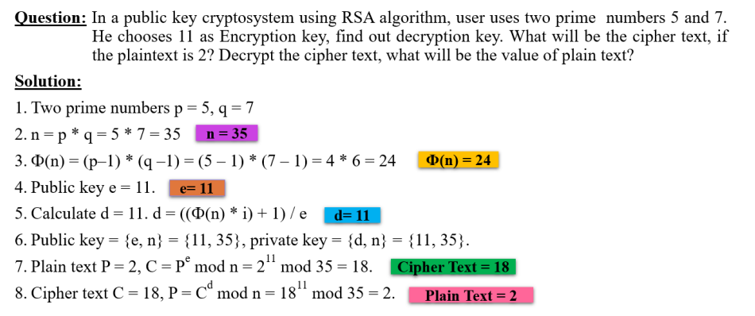
- 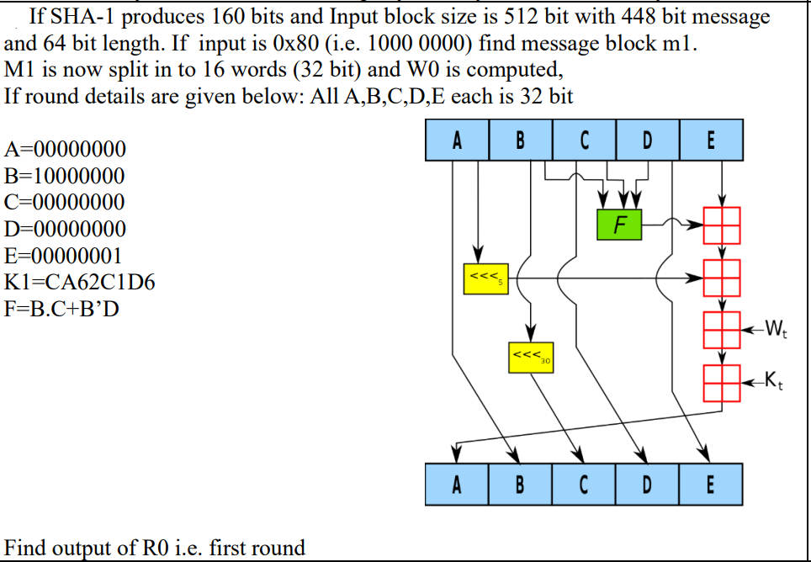

XXX --- 3 digit of roll number

