Course Name: | Digital Image Processing | Semester: | VII
Date of Performance: |  | Batch No:
Faculty Name: |  | Roll No:
Faculty Sign & Date: |  | Grade/Marks:

Experiment No: 5
Title: To study Morphological operations and Histogram stretching.

Aim and Objective of the Experiment:
To study Morphological operations and Histogram stretching

COs to be achieved:
- Understand fundamental theory and models of image processing

Theory:
Types of Morphological Operations
Morphology is a broad set of image processing operations that process images based on shapes. Morphological operations apply a structuring element to an input image, creating an output image of the same size. In a morphological operation, the value of each pixel in the output image is based on a comparison of the corresponding pixel in the input image with its neighbors.

Morphological Dilation and Erosion
The most basic morphological operations are dilation and erosion. Dilation adds pixels to the boundaries of objects in an image, while erosion removes pixels on object boundaries. The number of pixels added or removed from the objects in an image depends on the size and shape of the structuring element used to process the image. In the morphological dilation and erosion operations, the state of any given pixel in the output image is determined by applying a rule to the corresponding pixel and its neighbors in the input image. The rule used to process the pixels defines the operation as a dilation or an erosion. This table lists the rules for both dilation and erosion.
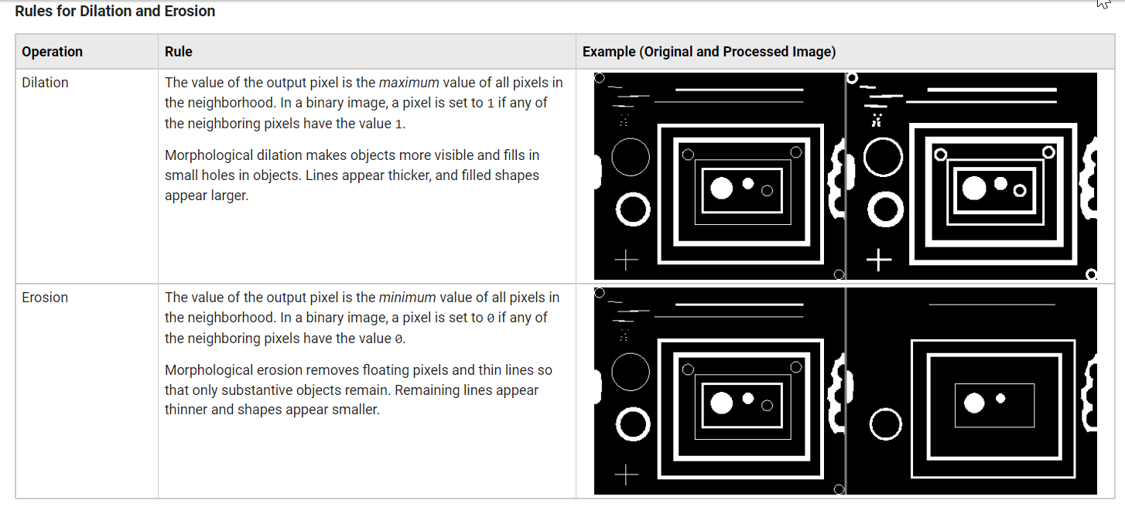
The following figure illustrates the dilation of a binary image. The structuring element defines the neighborhood of the pixel of interest, which is circled. The dilation function applies the appropriate rule to the pixels in the neighborhood and assigns a value to the corresponding pixel in the output image. In the figure, the morphological dilation function sets the value of the output pixel to 1 because one of the elements in the neighborhood defined by the structuring element is on. For more information, see Structuring Elements.
Morphological Dilation of a Binary Image
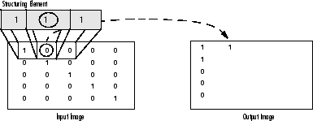
The following figure illustrates this processing for a grayscale image. The dilation function applies the rule to the neighborhood of the circled pixel of interest. The value of the corresponding pixel in the output image is assigned as the highest value among all neighborhood pixels. In the figure, the value of the output pixel is 16 because it is the highest value in the neighborhood defined by the structuring element.
Morphological Dilation of a Grayscale Image
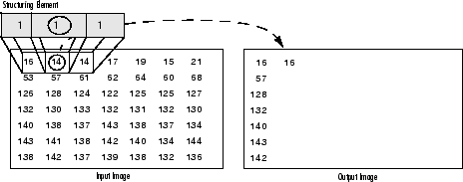

Operations Based on Dilation and Erosion
Dilation and erosion are often used in combination to implement image processing operations. For example, the definition of a morphological opening of an image is an erosion followed by a dilation, using the same structuring element for both operations. You can combine dilation and erosion to remove small objects from an image and smooth the border of large objects.
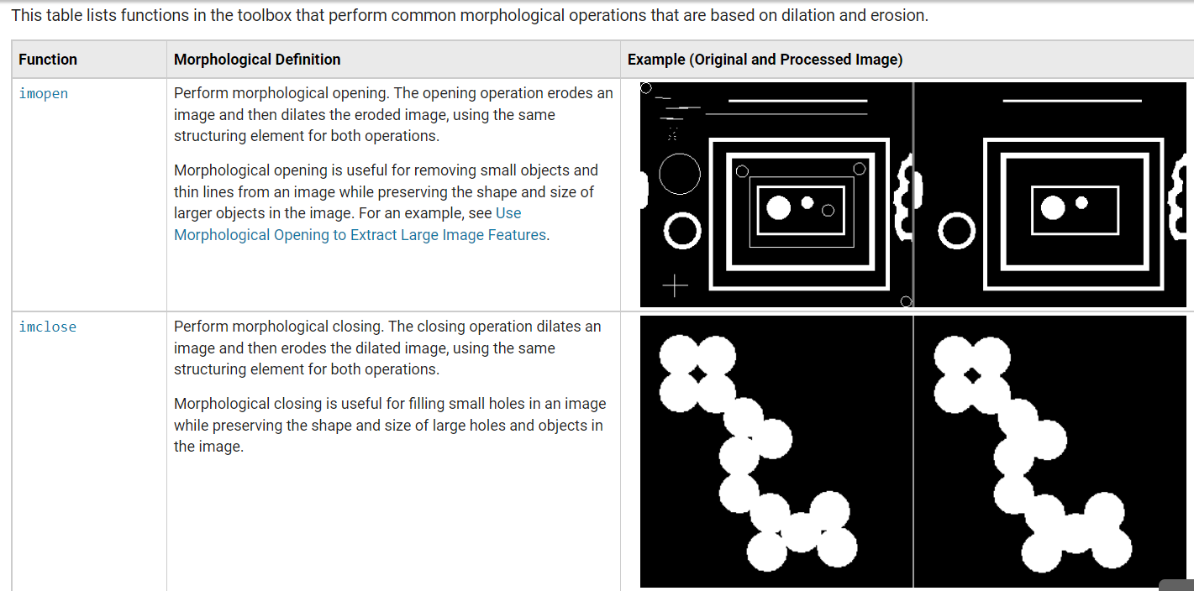
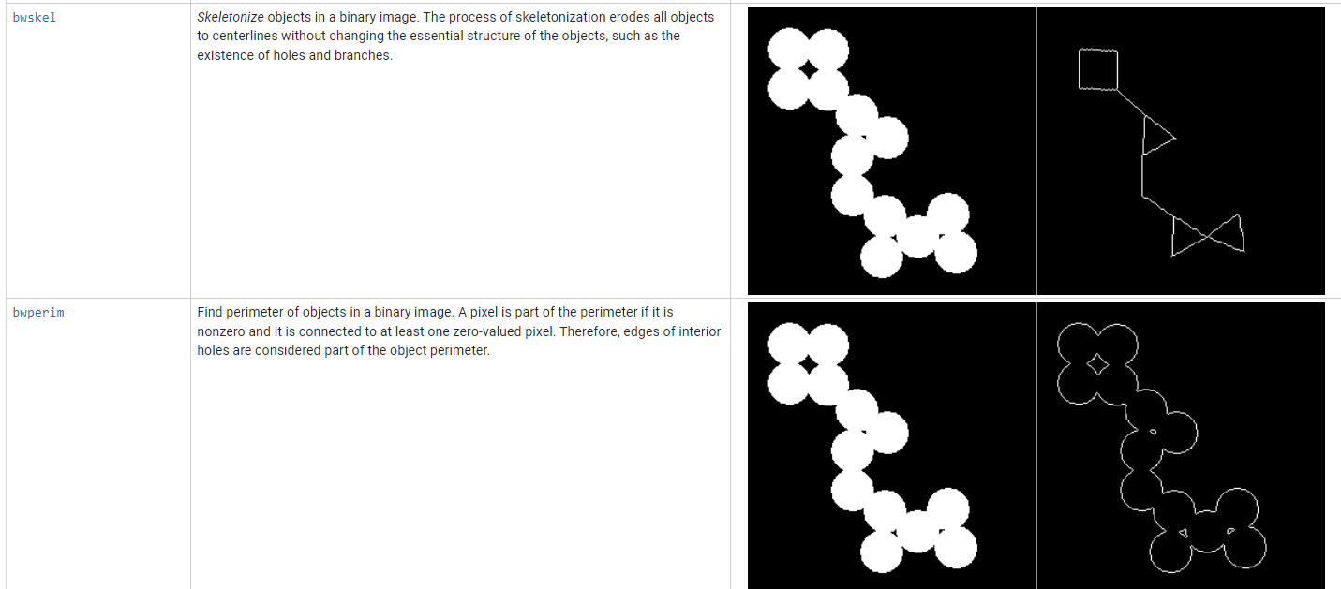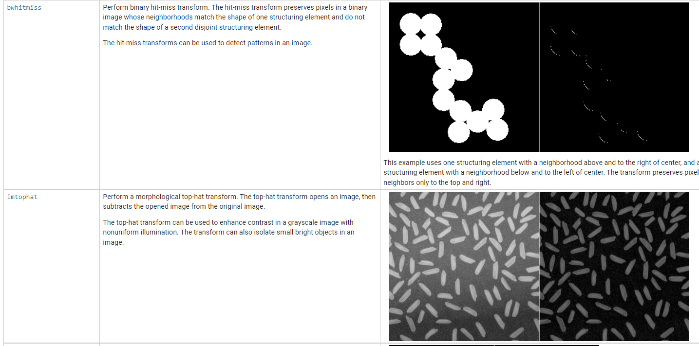
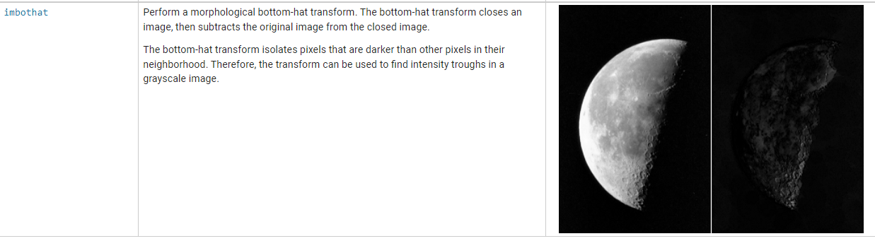

Contrast
Contrast is the difference between maximum and minimum pixel intensity.
Consider this image.
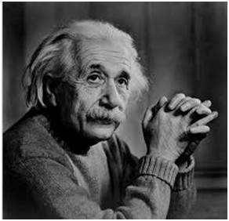
The histogram of this image is shown below.
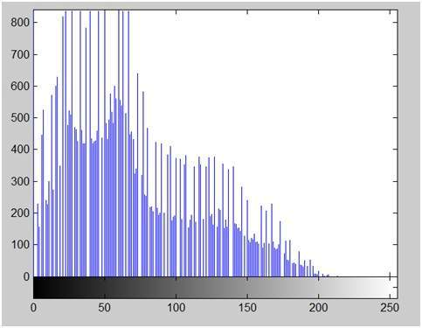
Now we calculate contrast from this image.
Contrast = 225.
Now we will increase the contrast of the image.

Increasing the contrast of the image
The formula for stretching the histogram of the image to increase the contrast is
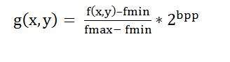
The formula requires finding the minimum and maximum pixel intensity multiply by levels of gray. In our case the image is 8bpp, so levels of gray are 256.
The minimum value is 0 and the maximum value is 225. So the formula in our case is
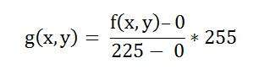
where f(x,y) denotes the value of each pixel intensity. For each f(x,y) in an image , we will calculate this formula.
After doing this, we will be able to enhance our contrast.
The following image appear after applying histogram stretching.
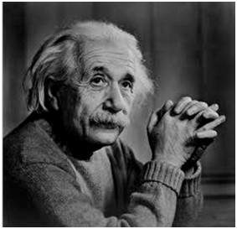
The stretched histogram of this image has been shown below.
Note the shape and symmetry of histogram. The histogram is now stretched or in other means expand. Have a look at it.
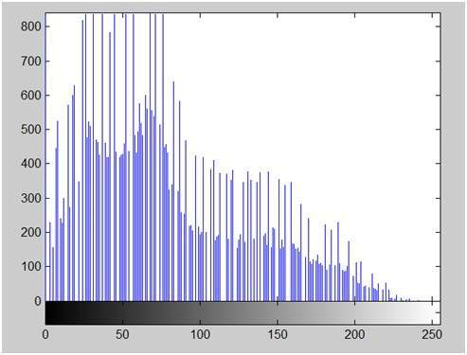
In this case the contrast of the image can be calculated as
Contrast = 240
Hence we can say that the contrast of the image is increased.
Note : this method of increasing contrast doesnot work always, but it fails on some cases.

Failing of histogram stretching
As we have discussed , that the algorithm fails on some cases. Those cases include images with when there is pixel intensity 0 and 255 are present in the image
Because when pixel intensities 0 and 255 are present in an image, then in that case they become the minimum and maximum pixel intensity which ruins the formula like this.
Original Formula
Putting fail case values in the formula:
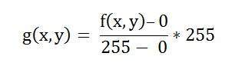
Simplify that expression gives
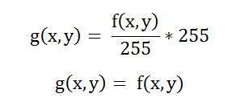
That means the output image is equal to the processed image. That means there is no effect of histogram stretching has been done at this image.

Stepwise-Procedure:
- Record Video on the mobile phone (use the Front camera)
- Transfer the video to a working PC
- Extract frame number 105 from the video
- Convert the image to grayscale
- Apply thresholding with varying levels and generate different binary images
- Apply morphological operation to extract shapes from the frame (erode, dilate, open, close)
- Get an old scratched photo or damaged photo
- Apply scratch removal logic or colour restoration
- Take the second frame from the video
- Apply ‘HSV’ histogram and recreate the image
- Repeat all steps in MATLAB/Python

Output
- Upload picture screenshots for all MATLAB

Conclusions:

Post Lab Subjective/Objective type Questions:
Answer the following questions:
- Explain the Different Morphological operations on the image

- What are different operations with Histogram one can perform

Signature of faculty in-charge with Date:

