Course Name: | Digital Electronics (116U40L303) | Semester: | III
Date of Performance: |  | Batch No:
Faculty Name: |  | Roll No:
Faculty Sign & Date: |  | Grade/Marks:

Experiment No: 4
Title: BCD Adder

Aim and Objective of the Experiment:
To study BCD Adder Using IC 7483

COs to be achieved:
CO2: Design combinational circuits using MSI devices.

Theory:
BCD (Binary Coded Decimal) addition and binary addition are both arithmetic operations performed on binary numbers, but they are designed for different purposes and have distinct characteristics. Let's break down how BCD addition is different from binary addition:
- Representation:
  - BCD: Binary Coded Decimal represents each decimal digit (0 to 9) using a 4-bit binary code. It is often used in applications where decimal arithmetic is essential, such as in financial calculations, displays, and input/output systems.
  - Binary: Binary numbers represent values in base-2 using only two digits, 0 and 1. It is the fundamental numeral system used in digital electronics and computing.
- Number Range:
  - BCD: BCD is restricted to representing decimal digits, so each BCD digit ranges from 0000 to 1001. BCD does not go beyond these values.
  - Binary: Binary numbers can represent any integer value, positive or negative, with a varying number of bits. The range is determined by the number of bits used in the representation.
- Addition Rules:
  - BCD: BCD addition involves adding two BCD digits, similar to binary addition, but with some specific rules to ensure the result stays within the valid BCD range (0 to 9). If the sum of two BCD digits is greater than 9, or if a carry occurs from a lower-order digit, a correction is needed to maintain BCD validity. Adding 6 (0110 in BCD) corrects the result while accounting for the carry.
  - Binary: Binary addition follows the same rules as BCD addition when it comes to carrying over digits, but there's no specific restriction on the range of values. The result of binary addition can be any binary value, and there's no need for correction to ensure validity.
- Purpose:
  - BCD: BCD addition is mainly used in applications where decimal calculations and accurate representation of decimal values are crucial, such as in calculators, digital displays, and financial systems.
  - Binary: Binary addition is the basis for all digital arithmetic and computation, including calculations in computer processors, memory operations, and general-purpose computation.
In summary, BCD addition and binary addition both involve the manipulation of binary numbers, but they serve different purposes. BCD addition is tailored for accurate decimal calculations and representation, while binary addition forms the foundation for all digital computation. BCD addition incorporates correction mechanisms to ensure valid decimal results within the limited range of decimal digits, whereas binary addition has a broader range of possible outcomes without specific restrictions.

Studying the BCD adder using the IC 7483 offers a practical insight into the world of digital arithmetic circuits and binary-coded decimal representations. The IC 7483 is a 4-bit binary adder that holds a unique significance in understanding how BCD numbers are processed and manipulated within digital systems. This exploration sheds light on how complex operations involving decimal digits are performed through binary manipulation.

The primary objective of this study is to comprehend the process of BCD addition using the IC 7483. Binary Coded Decimal (BCD) is a coding system that represents decimal digits using a 4-bit binary code. This code allows for the representation of decimal digits 0 to 9, with the first 10 4-bit combinations considered valid BCD representations.

The IC 7483 acts as a fundamental building block in this study. It consists of parallel binary adder circuits that are essential for performing the addition of BCD digits. The study involves connecting the BCD digits to the A and B inputs of the IC 7483 and analyzing the sum outputs (S) and carry outputs (Cout). The first adder circuit produces the initial binary sum output, which is then checked for invalid BCD values exceeding 9.

The study introduces an additional layer of complexity in the form of a combinational circuit that evaluates the sum outputs to detect invalid BCD values. When an invalid BCD value is detected, the combinational circuit triggers the need for correction. This correction process involves adding 6 (0110 in binary) to the original sum. This clever technique aligns with the binary manipulation required for BCD correction.

By engaging with the IC 7483 and the associated combinational circuit, learners gain hands-on experience in digital circuitry, binary arithmetic, error detection, and correction. This study bridges the gap between theoretical knowledge and practical application, fostering a deeper understanding of how digital systems operate on a fundamental level. The BCD adder using IC 7483 exemplifies the elegance and efficiency of digital design, where a simple circuit can orchestrate complex operations, ultimately contributing to the foundational knowledge of digital electronics and computation.

Truth Table: | K-Map for BCD Addition:

Logic Diagram of BCD Adder:
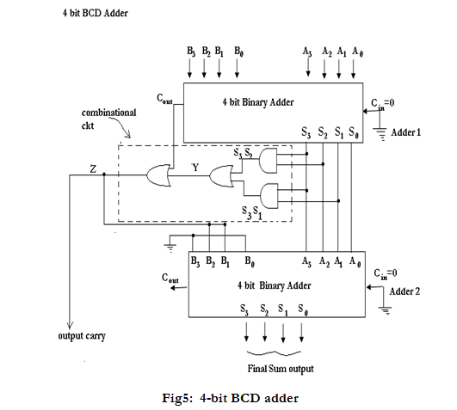

Stepwise-Procedure:
- Make a truth table of BCD adder.
- Obtain the expressions for sum and carry bit by solving K Map.
- Implement the obtained expressions on a trainer kit.
- Check for at least 5 cases using obtained expression to justify BCD adder.

Post Lab Subjective/Objective type Questions: (Must be handwritten)
      - How does a BCD adder ensure that the result of adding two BCD digits remains within the valid range of decimal digits (0 to 9)?
      - Explain the purpose of the combinational circuit in a BCD adder. How does it detect and correct invalid BCD values?
      - If you're adding the BCD digits 3 (0011 in BCD) and 8 (1000 in BCD), what will be the output of the BCD adder, and will any correction be needed?
      - Contrast the rules and correction mechanisms used in binary addition and BCD addition when a carry occurs during addition.
      - In a BCD adder, why is the value 6 (0110 in BCD) added to the sum output when invalid BCD values are detected? How does this correction process work to yield a valid BCD result?
      - Implement a one-digit BCD Subtractor.

Conclusion:

Signature of faculty in-charge with Date:

